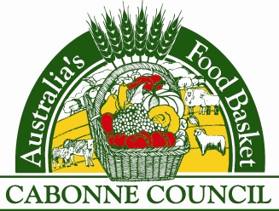

Planning Proposal

for

1. Nanima Street, Eugowra - currently zoned IN2 Light Industrial
2. Lot 164 DP 750159, Dripping Rock Road, Eugowra – currently zoned RU1, and
3. Correction of a mapping anomaly reference to Main Road 61

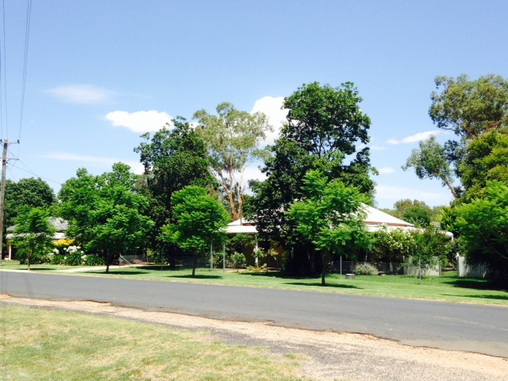

Prepared by Cabonne Council

December 2014

**CONTENTS**

**INTRODUCTION & BACKGROUND**

**PART 1 - OBJECTIVES OR INTENDED OUTCOMES**

**PART 2 – EXPLANATION OF THE PROVISIONS**

**PART 3 – JUSTIFICATION**

Section A – Need for the planning proposal

Section B – Relationship to strategic planning framework

Section C – Environmental, social and economic impact

Section D – State and Commonwealth interests

**PART 4 – MAPPING**

**PART 5 – COMMUNITY CONSULTATION**

**PART 6 – PROJECT TIMELINE**

**APPENDICES**

Appendix A – Director Environmental Services report and council minutes

Appendix B – Map of the sites to be reclassified

Appendix C – SEPPs checklist

Appendix D – Section 117 Directions checklist

**Introduction**

The Cabonne Local Environmental Plan (LEP) 2012 was implemented on 18 January 2013. As a result of the operation of the plan several matters have been identified that would benefit from a series of minor zone or mapping amendments.

The proposed changes to the LEP are as follows:

1. To rezone land at Eugowra from IN2 to RU5. The LEP 2012 included an area of approximately 19ha located within the southern section of the village of Eugowra as IN2 Light Industrial. The zoning was established to support existing industrial development located within the precinct and to encourage further development. The area contains a mix of land uses including industry, residential dwellings and vacant land.

Prior to the implementation of Cabonne LEP 2012 the subject area was zoned 2(v) Village by the former Cabonne LEP 1991. A draft Development Control Plan and the 2005 Eugowra village strategic plan however identified the majority of the precinct as a potential industrial area.

Since the implementation of the Cabonne LEP 2012 representatives of the Eugowra community, including many of the landowners within the newly zoned IN2 area, have opposed the zoning, seeking a return to the village zone to enable a broader mix of land use opportunities, particularly residential land use.

1. To rezone Lot 164 DP 750159 located off Dripping Rock Road, Eugowra from RU1 to E1 National Parks and Nature Reserve. Council was advised in March 2014 by Office of Environment & Heritage NSW National Parks & Wildlife Service (NPWS) were acquiring the 32ha allotment for inclusion with the adjacent Nangar National Park.
2. To amend a mapping anomaly on LEP numbered sheets 002 and 002A to replace reference to Main Road (MR) 61 from Federation Way to its gazetted title of Henry Parkes Way.

The Planning Proposal addresses each of the three (3) items under its various Parts in the following report.

**Background**

1. In July 2013 council received a development enquiry relating to the proposed purchase of a vacant allotment within the Nanima Street, Eugowra area for a truck depot and a dwelling. Resulting from this enquiry landowners in the vicinity informed council that they were unaware of the change to the zoning from village to industrial and were opposed to it. Representation from the Eugowra Progress and Promotion Association supported the landowners request to reverse the land zone. The issue has been the subject of approaches to council and the Department of Planning by the Eugowra community.

The zoning as established by the Cabonne LEP 2012 was in accordance with the Department’s advice during the LEP preparation/s65 consultation process, and was supported by the endorsed Cabonne Settlement Strategy.

Since the implementation of the Cabonne LEP 2012 it is noted that there has been no uptake of land in the Eugowra industrial zone and that there has been a continued request from property owners to return the area to a village zone to facilitate a wider mix of land use permissibility.

1. The acquisition of the allotment for inclusion in the Nangar National Park enables practical access to the park and ensures the protection and management of the existing relatively undisturbed mature white box woodland endangered ecological community found upon the allotment.
2. MR61 – formerly known as Federation Way was renamed Henry Parkes Way during 2010. The gazetted name change was inadvertently not updated on the draft LEP maps. Correcting the road name on the LEP plans will remove any confusion to the referencing of MR 61.

**Part 1 – Objectives or intended outcomes**

1. To rezone land at Eugowra from IN2 Light Industrial to RU5 Village consistent with the remainder of the village. The intended outcome is to permit a broader range of landuses including residential uses.
2. To rezone an allotment of land acquired by NPWS for inclusion in the adjacent Nangar National Park and to ensure an outcome that protects the remnant white box woodland endangered ecological community located upon that allotment.
3. To amend a mapping anomaly where MR 61 is correctly identified as Henry Parkes Way, rather than the former name of Federation Way. The intended outcome is to clarify the current road descriptor.

**Part 2 – Explanation of provisions**

1. To rezone land at Eugowra from IN2 Light Industrial to RU5 Village consistent with the remainder of the village. The intended outcome is to permit a broader range of landuses including residential uses.

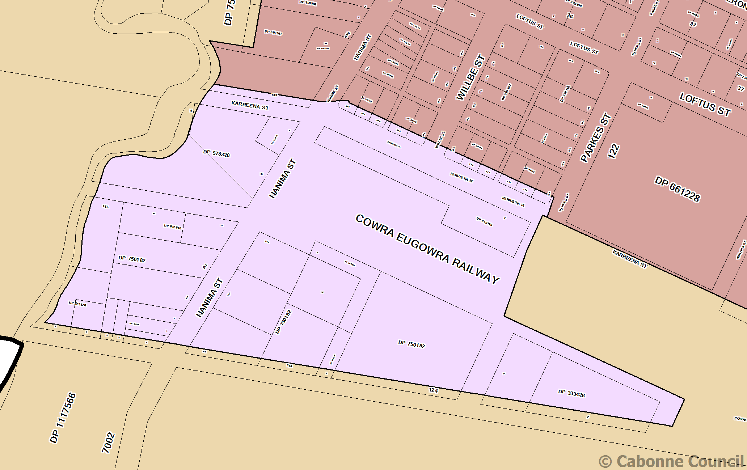

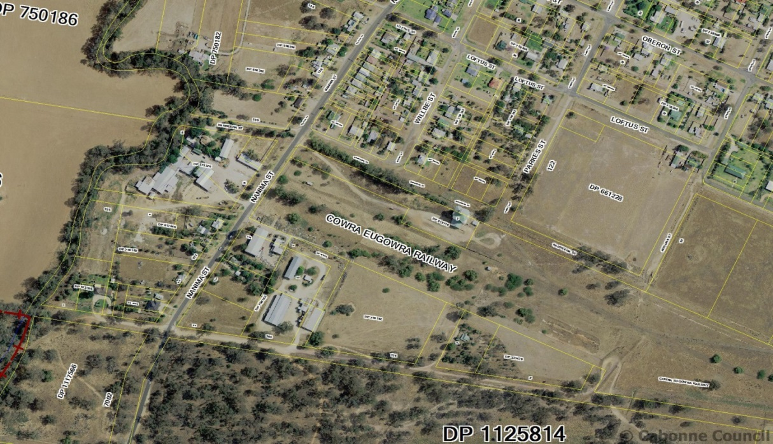

It is suggested that Land Zoning Map – Sheet LZN_003A be amended to remove the zone IN2 and replace it with zone RU5. Lot Size Map – Sheet LSZ_003A will also require amendment so that the subject area, currently shown as uncoloured on the map, is included in the 2,000m² minimum lot size area and edged blue to form part of “Area A”.

1. To rezone Lot 164 DP 750159, being an allotment of land acquired by NPWS for inclusion in the adjacent Nangar National Park, from RU1 to E1 ensure protection of remnant white box woodland endangered ecological community located upon that allotment.

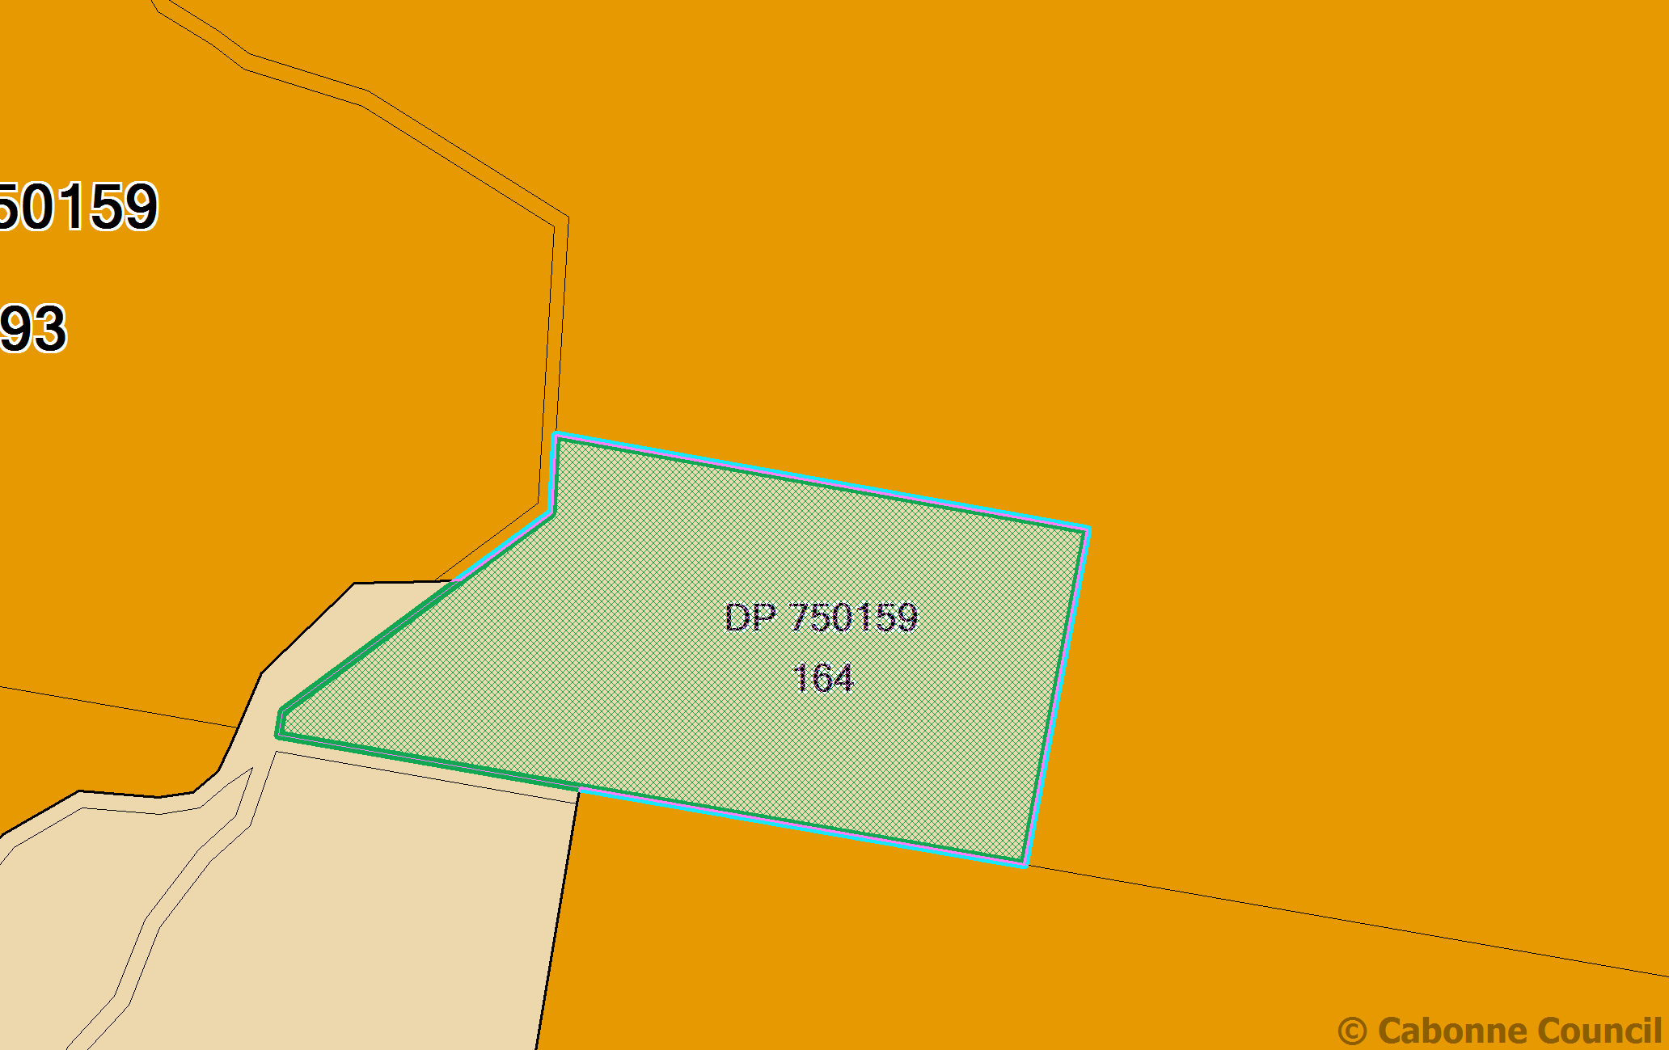

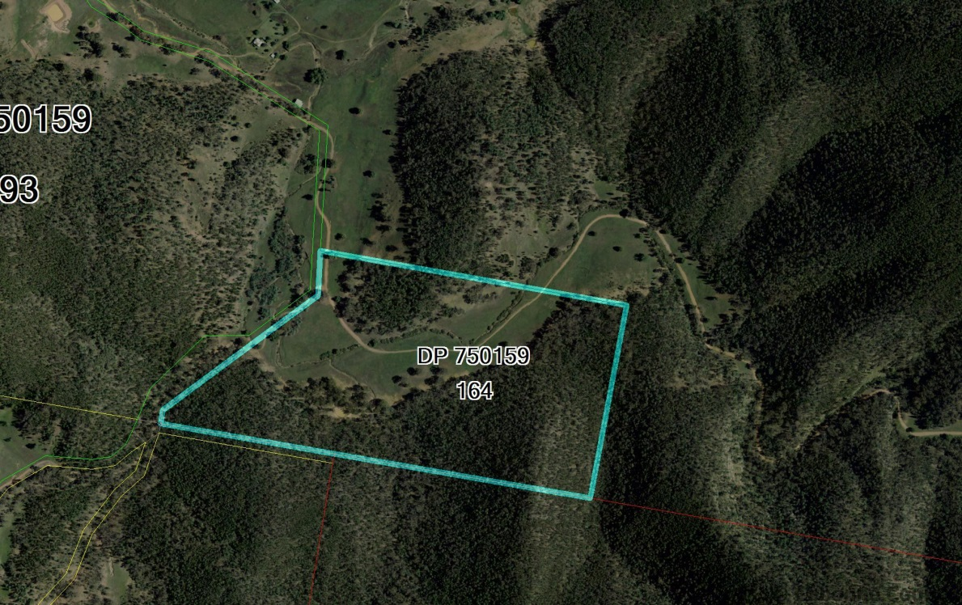

It is suggested that Land Zoning Map – Sheet LZN_003 be amended to remove zone RU1 from the subject land and replace it with zone E1. Lot Size Map – LSZ_003 is to be amended to remove the 100ha minimum lot size from the allotment and include it as uncoloured.

1. To amend a mapping anomaly so that MR 61 is correctly identified as Henry Parkes Way, rather than the former name of Federation Way. The intended outcome is to clarify the current road descriptor.

Following a joint proposal to the Roads and Traffic Authority from Parkes, Cabonne, Lachlan and Forbes Shire Councils Main Road 61 was named ‘Henry Parkes Way’ from its intersection with The Escort Way at ‘The Monument’, Boree (MR 377) through to Condobolin. The name was formally gazetted in 2010.

The Cabonne LEP 2012 incorrectly identifies MR 61 by its former name of Federation Way. The MR 61 within the Cabonne LGA commences at the intersection with The Escort Way and extends west through Manildra to the Local Government boundary with Parkes Council.

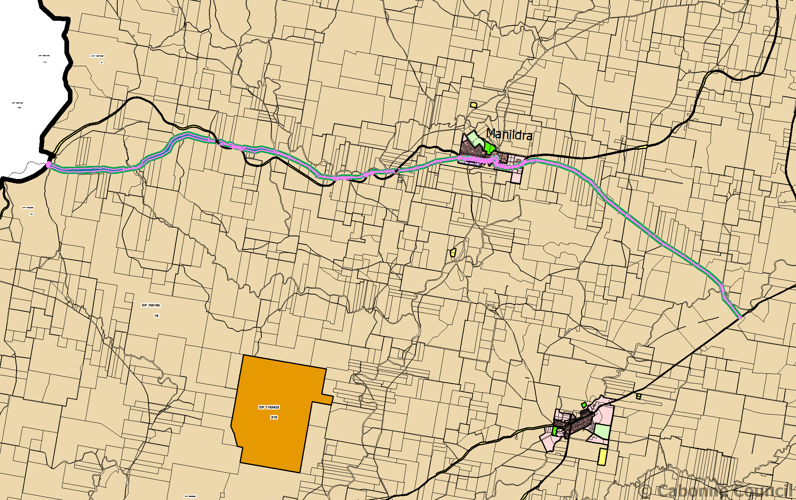

Location of Henry Parkes Way

To facilitate the correction each map within the Cabonne LEP 2012 series having the 002 and 002A identifier will require amendment to remove the words “Federation Way” and insert instead the words “Henry Parkes Way”.

**Part 3 – Justification**

**Section A – Need for the Planning Proposal**

**3.1 Is the Planning Proposal a result of any strategic study or report?**

The planning proposal is not the result of a specific study or report. The issues that the Planning Proposal addresses have been identified through operational experience with the new LEP and community feed back. Refer to Appendix A and B.

**3.2 Is the Planning Proposal the best means of achieving the objectives or intended outcomes, or is there a better way?**

The Planning Proposal achieves the intended outcomes identified in Part 2.

1. The Planning Proposal facilitates broader opportunities for economic development and employment.
2. The Planning Proposal recognises the acquisition of the freehold allotment for inclusion in the Nangar National Park. The zoning enhances the future management and protection of endangered ecology located upon the subject land.
3. The Planning Proposal seeks to amend a road naming anomaly and clarify identification of MR 61 within the Cabonne Council area.

**3.3 Is the Planning Proposal consistent with the objectives and actions of the applicable regional or sub-regional strategy?**

The planning proposal is consistent with the Blayney, Cabonne and Orange City councils Sub-regional rural and industrial land use strategy, July 2008.

1. While the sub-regional strategy identified land at Manildra for future industrial expansion it did not address provision of smaller scale industrial development demand and supply within the village of Eugowra. The strategic planning process associated with the introduction of the Standard Instrument LEP assessed demand and supply for industrial land for each of the Cabonne Council area towns and villages and sought to implement recommendations to promote industrial development within discrete areas, enhancing economic development opportunities while minimising potential for land use conflict.

The Eugowra community have requested the earlier village zone be reinstated to that area of land zoned IN2 by the Cabonne LEP 2012, based upon the RU5 zone permitting a broader range of permissible land uses, including dwellings.

Management of any potential land use conflict can be achieved by merit based development assessment, as currently applies to all development categories permissible in the adjacent established village zone.

**3.4 Is the planning proposal consistent with council’s local strategy or other local strategic plan?**

The Planning Proposal is consistent with the Cabonne Community Strategic Plan.

1. The 2012 Cabonne Settlement Strategy applies to this proposal. The strategy identified a potential requirement for industrial land at Eugowra over the next 5 - 10 years as approximately 2ha (based upon historic demand and supply information). The Settlement Strategy noted a concentration of existing light industrial activity at the southern edge of the village and proposed to designate the precinct by way of a light industrial zone to support the industries and to promote expansion opportunities. The strategy suggested only home industries low impact light industries should be supported in the RU5 zone.

The strategy also identified council owned land located upon rural land to the south of Eugowra as a future investigation area and potentially suitable for rural industrial development.

Demand for land within the IN2 zone for industrial purposes has been negligible in the past 2 years. To facilitate broader development opportunities the land owners and community seek rezoning to RU5 to permit a land use range consistent with the zoning for the remainder of the village.

**3.5 Is the Planning Proposal consistent with applicable State Environmental Planning Policies?**

The planning proposal is consistent with State Environmental Planning Policies (SEPPs). Refer to Appendix C

The provisions of SEPP 55 would apply to the planning proposal as the precinct contains a timber mill. Should future development be proposed upon that site, assessment would be required to identify any site contamination that may pose unacceptable risk to human health or the environment. Site soil testing would be required to confirm that the area is suitable for residential development. Council is satisfied that due process can be implemented to manage any future proposed change of land use that incorporates a residential component.

**3.6 Is the planning proposal consistent with applicable Ministerial Directions (s117 directions)?**

The planning proposal is consistent with relevant Ministerial Directions (s117 directions). Refer to Appendix D.

**3.7 Is there any likelihood that critical habitat or threatened species, populations or ecological communities, or their habitats, will be adversely affected as a result of the planning proposal?**

1. The planning proposal does not apply to land that has been identified as containing critical habitats or threatened species, populations or ecological communities, or their habitats.

2. The Planning Proposal seeks to rezone an allotment of land acquired by NPWS to ensure conservation and management of endangered white box ecological community.

3. Correcting a minor mapping anomaly will have no impact upon critical habitats or threatened species, populations or ecological communities, or their habitats

**3.8 Are there any other environmental effects as a result of the planning proposal and how are they proposed to be managed?**

1. The precinct is bounded to the west by Mandagery Creek with part of the subject land subject to flood inundation being within a flood way. Overland flow paths from the Puzzle Flat Creek catchment also impact upon land to the east of Nanima Street. The latter area is subject to low volume, low velocity impact. As much of the village of Eugowra is subject to floodway or flood inundation existing planning controls are in place to assess and manage development within these area. The planning proposal does not alter the existing controls. The subject precinct when previously zoned 2(v) Village under the provisions of the Cabonne LEP 1991 was subject to local planning controls and State regulations regarding development of flood prone land.

2. No significant environmental effects are anticipated.

3. No.

**3.9 Has the Planning Proposal adequately addressed any social and economic benefits?**

1. The Planning Proposal will provide diversity to the potential land use mix with potential for social and economic benefit to the Eugowra community.

2. The Planning Proposal is not considered to have any significant social or economic effects.

3. The Planning Proposal is not considered to have any significant social or economic effects.

**3.10 Is there adequate public infrastructure for the planning proposal?**

The planning proposal is unlikely to create any significant additional demands on public infrastructure.

**3.11 What are the views of State and Commonwealth public authorities consulted in accordance with the gateway determination?**

1. Initial advice from the Department of Planning has been that a Planning Proposal is the appropriate process to implement the rezoning. No formal consultation has been carried out of other agencies at this time.

2. NPWS advised council of the acquisition of the allotment. Management of the subject land will be in accordance with the Nangar National Park Plan of Management.

3. No specific consultation has been undertaken other than the consultation undertaken with Draft Cabonne LEP 2012. Should the Gateway Determination identify any additional consultations these would be undertaken.

**Part 4 – Mapping**

1. Eugowra IN2 land to be rezoned RU5

Extract from Cabonne LEP 2012 showing zoning of Nanima Street, Eugowra subject land

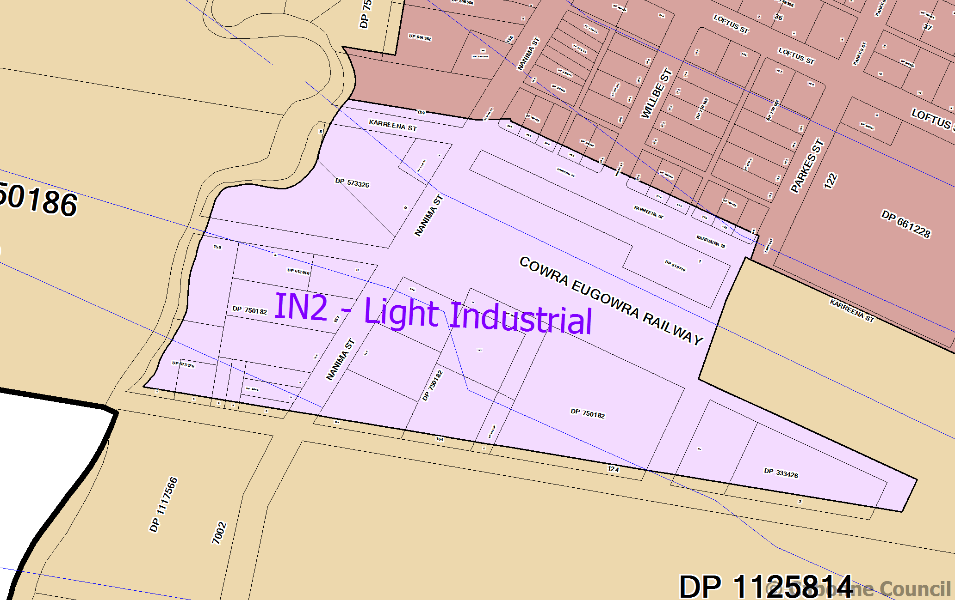

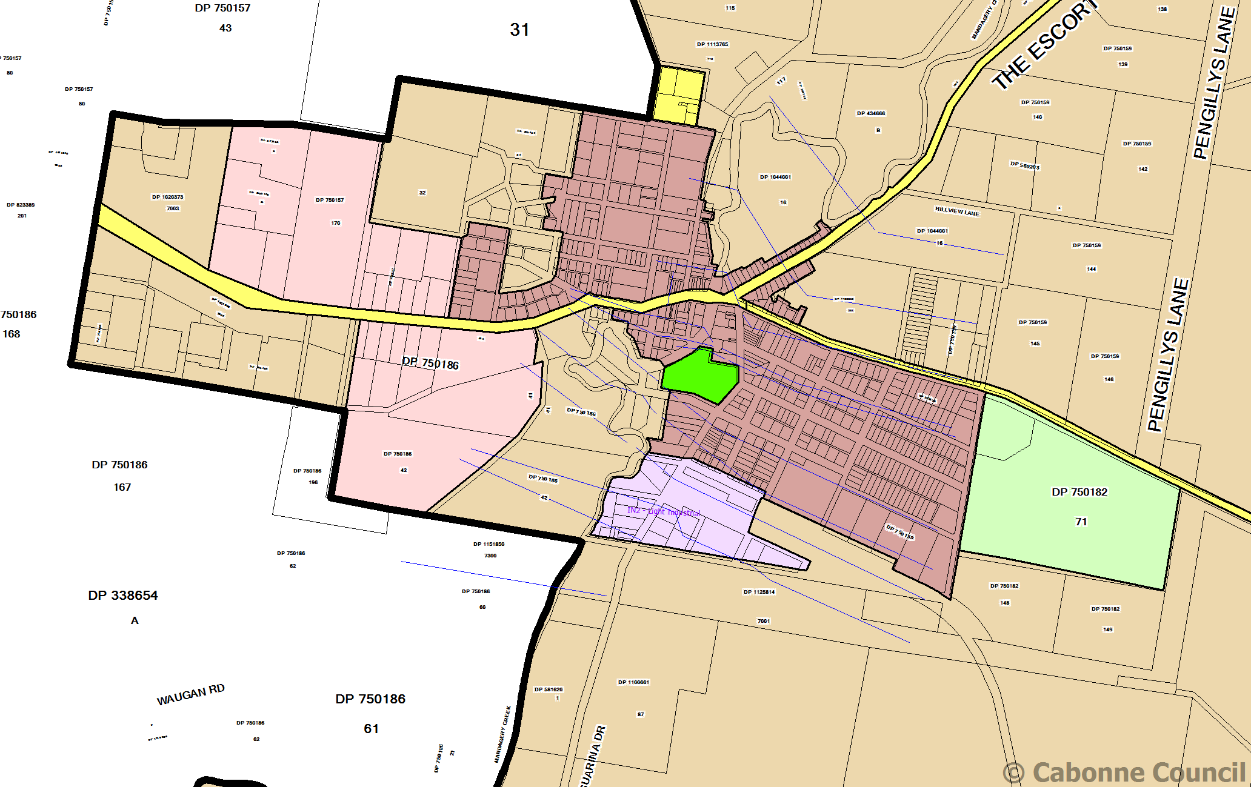

**Plan 3 – Aerial photo showing Eugowra village subject land**

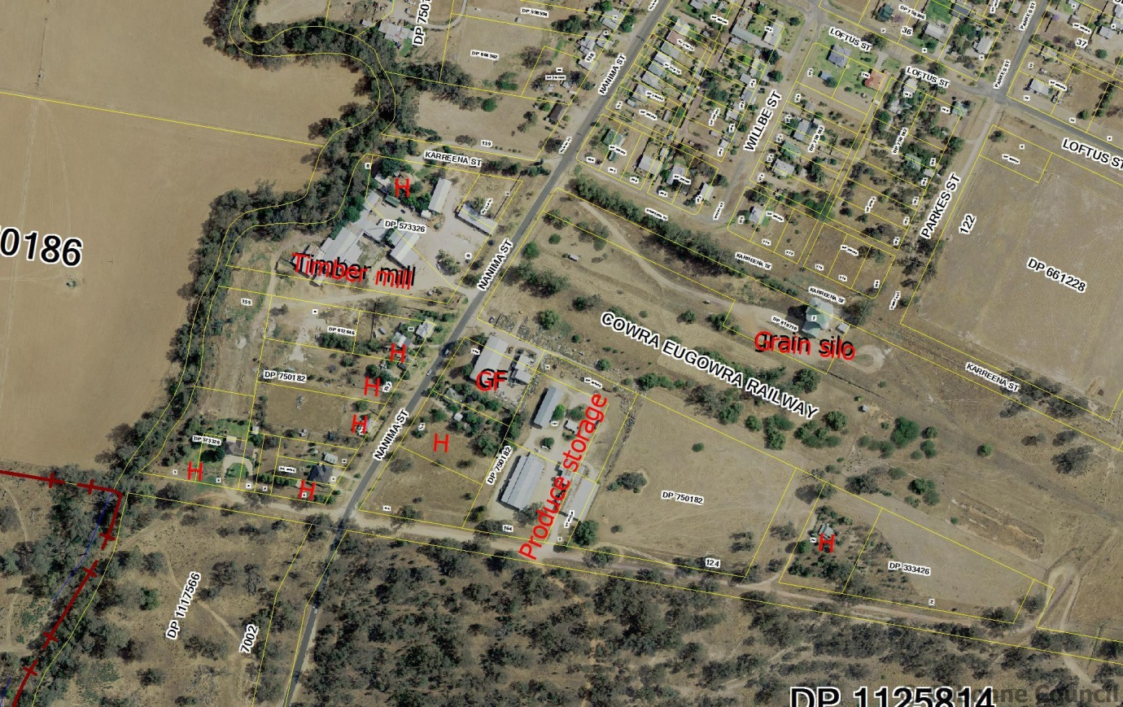

**KEY**

Timber Mill

Grain Silo

Produce storage sheds

GF – Granite factory

H – existing dwelling (8)

Land ownership details, including identification of those landowners petitioning council for village rezoning at Eugowra

|  |  |  |  |  |
| --- | --- | --- | --- | --- |
| **Landowner** | **Lot description** | **Existing land use** | **Area** | **Seeking rezoning** |
| Canowindra Produce P/L | Lot 1 DP 819710 | silo | 1.014ha | No contact from owner |
| State Rail c/- John Holland Group | Cowra/Eugowra Railway | Disused railway corridor | 3.3ha | No contact from owner |
| Ingesole & Long | Lot 2 DP 333426 | vacant | 1.012ha | Yes |
| Ingesole & Long | Lot 1 DP 333426 | House and land | 5,381m² | Yes |
| Donaldson | Lot 124 DP 750182 | vacant | 2.109ha | Yes |
| Eugowra Produce Milling Co (Forbes) P/L | Lot 161 & 164 DP 750182, Lot 1 DP 726959 & Lot 1 DP 653136 | Produce storage shed | 1.55ha | No contact from owner |
| Rue | Lot 163 DP 750182  Nanima Street | vacant | 4,982m² | Yes |
| Rue | Lot 162 DP 750182  Nanima Street | House and land | 4,805.7m² | Yes |
| Morris | Lot 160 DP 750182  Nanima Street | Granite factory | 4,262m² | No contact from owner |
| Hay P/L | Lot 1 DP 544925  Nanima Street | vacant | 1,891m² | Yes |
| Hay P/L | Lot 9 DP 573326 | House and saw mill | 8,022m² | Yes |
| Hay P/L | Lot 10 DP 573326 | Saw mill | 1.229ha | Yes |
| Hay P/L | Lot 10 DP 612646 | vacant | 3,300m² | Yes |
| Hay P/L | Lot 155 DP 750182 | vacant | 5,514m² | Yes |
| Hay P/L | Lot 7 DP 573326 | vacant | 4,649m² | Yes |
| Hay & Hay | Lot 6 DP 573326 | house | 1,800m² | Yes |
| Dixon & Dixon | Lot 5 DP 573326 | vacant | 822m² | Yes |
| Dixon & Dixon | Lots 2 & 3 DP 16986 Nanima Street | house | 980m²  1,094m² | Yes |
| Dixon & Dixon | Lot 1 DP 16986 | vacant | 1,220m² | Yes |
| Stanley & Bray | Lot 158 DP 750182 | House and land | 5,134m² | Yes |
| Hoswell | Lot 157 DP 750182 | House and land | 5,160m² | Yes |
| Dent | Lot 11 DP 612646 | House and land | 2,490m² | Yes |

1. Lot 164 DP 750159, off Dripping Rock Road, Eugowra

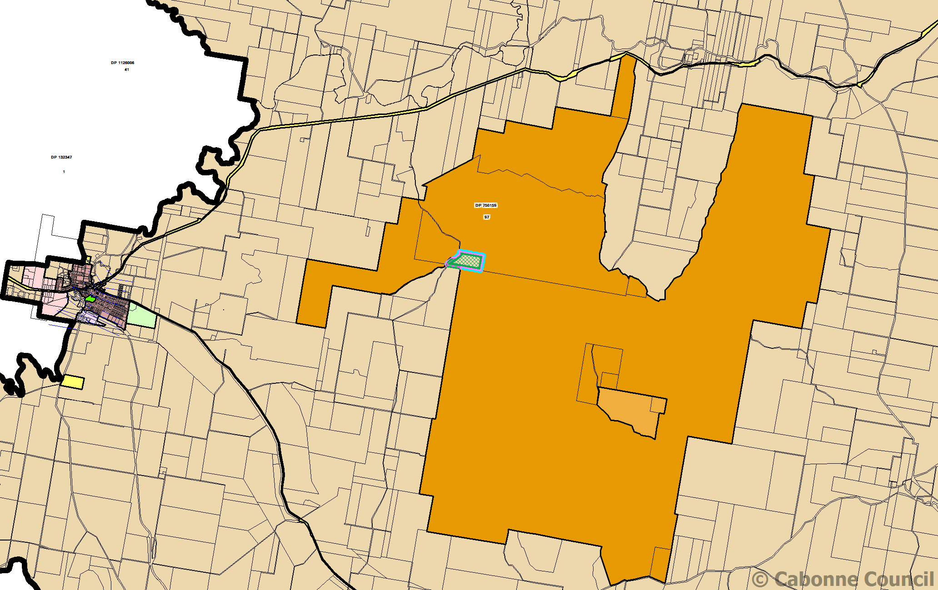

Location plan

3. Henry Parkes Way



Location of Henry Parkes Way within Cabonne LGA

**Part 5 – Community consultation**

For the purpose of public notification the planning proposal is considered that a 28 day exhibition period be held to ensure consultation with all stakeholders and any relevant government agencies.

1. The community consultation will involve:

* Notice in the Forbes newspaper at the start of the exhibition period
* Notice in the Eugowra community newsletter during the exhibition period
* Notice on council’s web site for the duration of the exhibition period
* Written notification to landowners within the precinct identified for rezoning
* Written notification sent to landowners adjacent to the subject precinct

1. The community consultation will involve:

* Notice in the Forbes newspaper at the start of the exhibition period
* Notice in the Eugowra community newsletter during the exhibition period
* Notice on council’s web site for the duration of the exhibition period
* Written notification to landowners of the allotment identified for rezoning
* Written notification sent to landowners adjacent to the subject precinct.

1. The community consultation will involve:

* Notice in the Orange newspaper at the start of the exhibition period
* Notice in the Manildra community newsletter during the exhibition period
* Notice on council’s web site for the duration of the exhibition period
* Written notification to the Roads & Maritime Services (RMS)

The written advice will contain:

* A brief description of the objectives or intended outcomes of the planning proposal
* An indication of the land affected by the planning proposal
* Information on where and when the planning proposal can be inspected
* The contact details of the council for receipt of submissions
* The closing date for submissions

During the public exhibition period the following documents will be placed upon public exhibition:

* The planning proposal
* The Gateway Determination
* Relevant council reports

The above mentioned documents will be available at the following locations during the public exhibition period:

* Cabonne Council office – 101 Bank Street, Molong, and
* Cabonne Council office – Main Street, Cudal

A public hearing will not be required to be held upon conclusion of the public exhibition phase.

Public exhibition of the Planning Proposal would be carried out in accordance with the requirements of the Environmental Planning & Assessment Act, Environmental Planning Regulations and the Gateway Determination.

**Part 6 – Project timeline**

The anticipated project timeline for completion of the Planning Proposal is outlined below:

|  |  |  |  |
| --- | --- | --- | --- |
| **No** | **Task** | **Commencement** | **Completion** |
| 1 | Gateway determination  Obtain Gateway Determination | January 2015 | February 2015 |
| 2 | Public Exhibition  Agency and community consultation to be undertaken as part of the formal public exhibition of the planning proposal in accordance with any conditions of the Gateway Determination | February 2015 | March 2015 |
| 3 | Consider submissions and document finalisation  Council staff to consider, respond and report to council on any submissions received and issues raised, and make any relevant changes to the planning proposal.  This process will determine amongst other things, the following:   * Whether or not to endorse and/or support the planning proposal * Whether or not to endorse the planning proposal (as exhibited); or * Whether or not to endorse the planning proposal (as amended) | March 2015 | April 2015 |
| 5 | Submission to the Department and/or Parliamentary Counsel  Council to forward the planning proposal to the department and/or Parliamentary Counsel following public exhibition (including and changes made). | May 2015 | June 2015 |
| 6 | Notification  Notification of LEP amendment being made | July 2015 | July 2015 |

**APPENDIX A**

**Planning report to Council 19 August 2014**

**‘Director of Environmental Services' REPORT**

The Cabonne Local Environmental Plan (LEP) 2012 has been in effect for the past 18 months. Review and refinement of the LEP is part of the ongoing process of land use planning. Council has recently implemented a Planning Proposal to amend anomalies with the classification of land at Molong from community to operational land. Likewise, discussions are well advanced with several landowners who are developing Planning Proposals for future submission to council to seek rezoning of land in accordance with sub regional industrial and rural strategy.

A series of matters have been identified as requiring adjustment to the principal LEP. Three separate matters are summarised below:

**Eugowra – request to rezone land from industrial to village**

As councillors will be aware Council has received requests from the Eugowra community to facilitate a Planning Proposal to revert the zoning of land situated in Nanima Street and zoned IN2 Light Industrial under the Cabonne LEP 2012 to RU5 Village. Council has received correspondence from the Eugowra Progress and Promotion Association dated 27 July 2014 requesting the rezoning of the Nanima Street land and submitting a petition signed by the majority of the 13 landowners in that area. Residents of the area seek a review of zone to revert the area’s land use zone to a village zone, thereby permitting a wider range of land uses, including residential use of land.

Preliminary discussions were held with the Department of Planning Western Region office staff in January 2014 to raise the Eugowra industrial/village zone proposal. A subsequent discussion was held with the office in May at which time it was indicated that the department was not opposed to considering a Planning Proposal to revert to the village zone.

**Eugowra - acquisition of additional land for inclusion in the national park**

Council has also received notification from the NSW Office of Environment and Heritage (NSW National Parks and Wildlife Service) that it has acquired a 32ha holding being Lot 164 DP 750159, along the Dripping Rock Road north east of Eugowra. The land is to be added to the Nangar National Park and will enable secure access for vehicles via the Terarra Creek Track while conserving relatively undisturbed white box woodland endangered ecological community that is found on the remainder of the property.

The Nangar land is currently zoned RU1 Primary Production under the Cabonne LEP, however with the addition of the holding to the National Parks it would be appropriate to rezone the acquired holding to E1 National Parks and Nature Reserve being the zone applying to the existing surrounding National Park land.

Discussions were undertaken with the Acting Team Leader, Land Assessment, Park Conservation and Heritage office in April 2014 where it was identified that rezoning of the Nangar land as part of the National Park was appropriate.

**Mapping Correction**

It has also been recently noted that the Cabonne LEP mapping sheets 002 and 002A refer to MR 61 as Federation Way. The road has been renamed Henry Parkes Way and it is suggested that the LEP maps be amended to reflect the current road name of the main road.

**Summary**

Council endorsement is sought to prepare the Planning Proposal to (1) rezone the Nanima Street, Eugowra industrial precinct to R5 Village, (2) rezone Lot Lot 164 DP 750159 now forming part of the Nangar national park from RU1 Primary Production to E1 National Parks and Nature Reserve, and (3) amend a mapping anomaly to replace reference to MR 61 from Federation Way to Henry Parkes Way. Subject to council’s endorsement staff will commence drafting a planning proposal for further consideration by council prior to submission of the documentation to the Department of Planning for determination under the Gateway Process.

**Site locations at Eugowra**

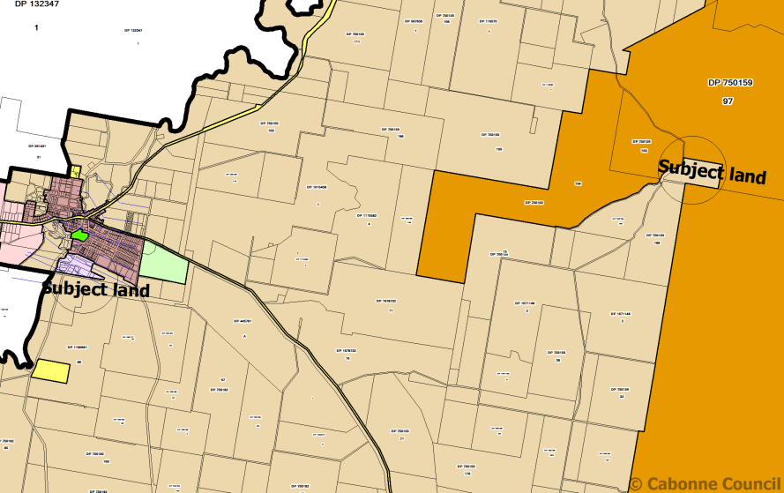

Site location – Nangar National Park

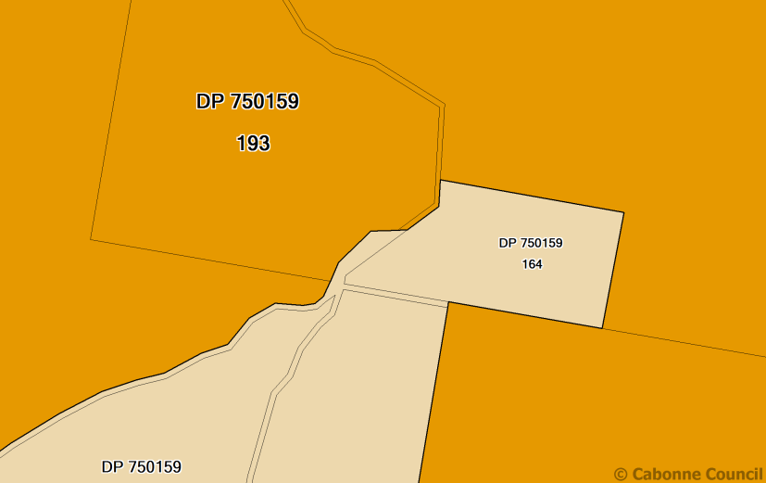

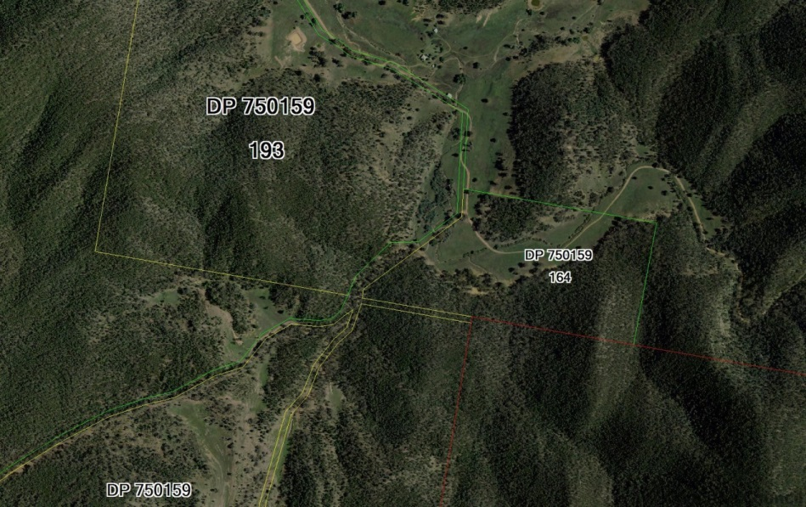

Aerial map - site at Nangar National Park

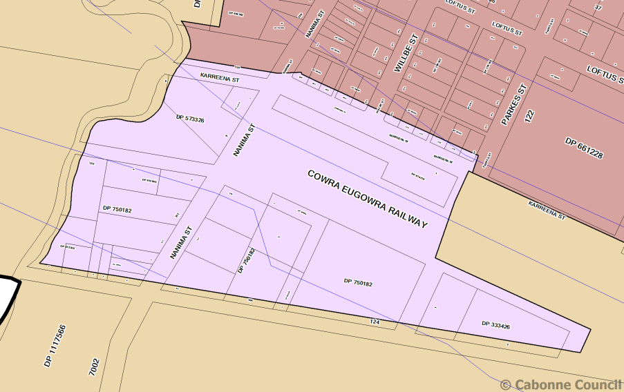

Site - Eugowra township subject land

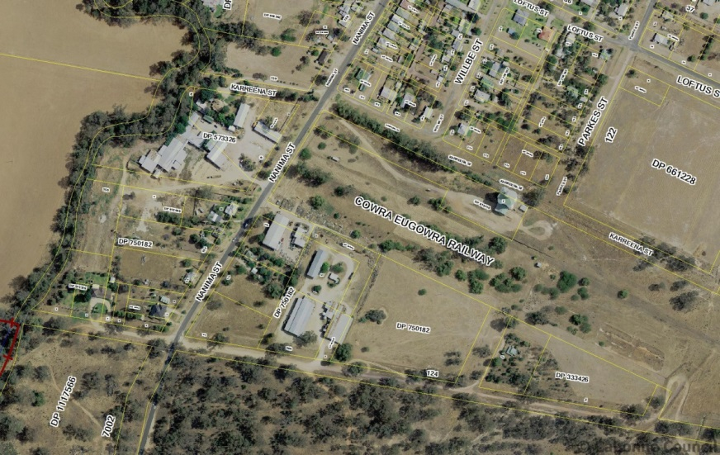

Aerial photo – Eugowra township subject land’

**Extract from Council Minutes of meeting of 19 August 2014:**

|  |  |
| --- | --- |
|  | ITEM - 21 PLANNING PROPOSAL - LEP 2012 AMENDMENT |
|  | Proceedings in Brief  Council added point 4 to the recommendation due to concerns about unspecified costs involved in the proposed changes. |
|  | **MOTION** (Hayes/Wilcox)  THAT:  1. A Planning Proposal be prepared to rezone or rename the following land:  (a) The area of land located east and west of Nanima Street, Eugowra zoned IN2 Light Industry by Cabonne Local Environmental Plan 2012 to be rezoned RU5 Village;  (b) Lot 164 DP 750159 off Dripping Rock Road, Eugowra, zoned RU1 Primary Production by Cabonne Local Environmental Plan 2012 to be rezoned E1 National Parks and Nature Reserve;  (c) Correct a mapping anomaly on numbered sheets 002 and 002A to replace reference to MR 61 from Federation Way to its current title of Henry Parkes Way.  2. The Planning Proposal be forwarded to the Department of Planning and Infrastructure for Gateway Determination in accordance with section 56 of the Environmental Planning and Assessment Act.  3. A further report be provided to Council following the public exhibition period to provide details of any submissions received throughout that process upon completion of the Planning Proposal.  4. A report be provided to Council with full costs from commencement to conclusion for a) to c) above, including staff time costs. |
|  | Carried  The Chair called for a Division of Council as required under Section 375A (3) of the Local Government Act which resulted in a vote for the motion (noting the absence of Clrs Treavors and Walker – apologies) as follows:  For: Clrs Gosper, Dean, MacSmith, Hayes, Wilcox, Smith and Davison.  Against: Nash (abstained), Durkin, Culverson (abstained). |

**APPENDIX B**

**EUGOWRA IN2 AREA PHOTOGRAPHS**

|  |  |
| --- | --- |
| C:\Users\nichollh\AppData\Local\Microsoft\Windows\Temporary Internet Files\Content.Outlook\GRIMB0L5\photo 1 (3).JPG  Abandoned rail line adjacent to silo | C:\Users\nichollh\AppData\Local\Microsoft\Windows\Temporary Internet Files\Content.Word\photo 3.jpg  Canowindra Produce - silo |
| C:\Users\nichollh\AppData\Local\Microsoft\Windows\Temporary Internet Files\Content.Word\photo 3.jpg  View south along Nanima Street | C:\Users\nichollh\AppData\Local\Microsoft\Windows\Temporary Internet Files\Content.Word\photo 2.jpgSaw mill, Nanima Street |
| C:\Users\nichollh\AppData\Local\Microsoft\Windows\Temporary Internet Files\Content.Word\photo 1.jpgGranite factory, Nanima Street | C:\Users\nichollh\AppData\Local\Microsoft\Windows\Temporary Internet Files\Content.Word\photo 1.jpg  Granite factory and produce storage |

|  |  |  |
| --- | --- | --- |
| C:\Users\nichollh\AppData\Local\Microsoft\Windows\Temporary Internet Files\Content.Word\photo 2.jpg  Nanima Street residence | C:\Users\nichollh\AppData\Local\Microsoft\Windows\Temporary Internet Files\Content.Word\photo 1.jpg  Nanima Street residence | |
| C:\Users\nichollh\AppData\Local\Microsoft\Windows\Temporary Internet Files\Content.Word\photo 1.jpg  Nanima Street residence | C:\Users\nichollh\AppData\Local\Microsoft\Windows\Temporary Internet Files\Content.Word\photo 2.jpg  Nanima Street residence | |
| C:\Users\nichollh\AppData\Local\Microsoft\Windows\Temporary Internet Files\Content.Word\photo 2.jpg  Nanima Street residence | C:\Users\nichollh\AppData\Local\Microsoft\Windows\Temporary Internet Files\Content.Word\photo.jpg  Residence off Nanima street | |
| C:\Users\nichollh\AppData\Local\Microsoft\Windows\Temporary Internet Files\Content.Word\photo 2.jpg  Garden area off Nanima Street | | |
| C:\Users\nichollh\AppData\Local\Microsoft\Windows\Temporary Internet Files\Content.Word\photo 3.jpg  Vacant land Cnr Nanima St and Crown lane | | C:\Users\nichollh\AppData\Local\Microsoft\Windows\Temporary Internet Files\Content.Word\photo 1.jpg  View NW towards Nanima St |
| C:\Users\nichollh\AppData\Local\Microsoft\Windows\Temporary Internet Files\Content.Word\photo 2.jpg  Eugowra Produce – storage shed | | C:\Users\nichollh\AppData\Local\Microsoft\Windows\Temporary Internet Files\Content.Word\photo 1.jpg  Eugowra Produce – storage shed |
| C:\Users\nichollh\AppData\Local\Microsoft\Windows\Temporary Internet Files\Content.Word\photo 1.jpg  Vacant land off crown lane | | C:\Users\nichollh\AppData\Local\Microsoft\Windows\Temporary Internet Files\Content.Word\photo 2.jpg  Vacant land off crown lane |

**APPENDIX C**

**State Environmental Planning Policies (SEPP) checklist**

|  |  |  |  |
| --- | --- | --- | --- |
| **No.** | **SEPP Title** | **Applicable to Planning Proposal** | **Consistency** |
| 1 | Development Standards | No – does not apply to land in Cabonne Local Government Area (LGA) since implementation of Cabonne Local Environmental Plan (LEP) 2012 | N/A |
| 4 | Development without consent – Miscellaneous exempt & complying development | No – does not apply to land in Cabonne Local Government Area (LGA) since implementation of Cabonne Local Environmental Plan (LEP) 2012 | N/A |
| 6 | Number of storeys in a building | Not applicable | N/A |
| 14 | Coastal wetlands | Not applicable | N/A |
| 15 | Rural land sharing communities | Not applicable | N/A |
| 19 | Bushland in urban areas | Not applicable | N/A |
| 21 | Caravan Parks | Not applicable | N/A |
| 22 | Shops and commercial premises | No | No shops and commercial premises would be affected |
| 26 | Littoral rainforests | Not applicable | N/A |
| 29 | Western Sydney Recreation Area | Not applicable | N/A |
| 30 | Intensive agriculture | Not applicable | N/A |
| 32 | Urban Consolidation (Redevelopment of urban land) | Not applicable | N/A |
| 33 | Hazardous and Offensive industry | Not applicable | N/A |
| 36 | Manufactured home estate | Not aplicable | N/A |
| 39 | Split Island Bird Habitat | Not applicable | N/A |
| 44 | Koala Habitat Protection | Not applicable to the Nanima Street rezoning. Consistent with the objective to conserve land forming part of a national park. | The proposal is consistent with the SEPP |
| 47 | Moore Park Showground | Not applicable | N/A |
| 50 | Canal Estate Development | Not applicable | N/A |
| 52 | Farm dams and other works in land and waste management plan areas | Not applicable | N/A |
| 55 | Remediation of land | Not applicable to rezoning. Should future development including subdivision of existing industrial sites occur SEPP 55 will apply to development assessment | N/A |
| 59 | Central Western Sydney Regional Open Space and Residential | Not applicable | N/A |
| 60 | Exempt & Complying Development | No – does not apply to land in Cabonne Local Government Area (LGA) since implementation of Cabonne Local Environmental Plan (LEP) 2012 | N/A |
| 62 | Sustainable aquiculture | Not applicable | N/A |
| 64 | Advertising and signage | Not applicable | N/A |
| 65 | Design Quality of residential flat development | Not applicable | N/A |
| 70 | Affordable housing | Not applicable | N/A |
| 71 | Coastal protection | Not applicable | N/A |
|  | Affordable renting housing | Not applicable | N/A |
|  | Building Sustainability Index:BASIX 2004 | Not applicable | N/A |
|  | Exempt and Complying Development Codes 2008 | Not applicable | The planning proposal is not inconsistent with the aims and functions of the SEPP |
|  | Housing for seniors and people with a disability 2004 | Applicable | The planning proposal is not inconsistent with the SEPP |
|  | Infrastructure 2007 | Not Applicable | N/A |
|  | Kosciuszko National Park Alpine Resorts 2007 | Not Applicable | N/A |
|  | Major Developments 2005 | Not applicable | N/A |
|  | Mining, Petroleum Production and Extractive Industries | Not Applicable | N/A |
|  | Rural lands 2008 | Not applicable | N/A |
|  | State & regional development 2011 | Not applicable | N/A |
|  | Sydney Drinking Water Catchment 2011 | Not applicable | N/A |
|  | Sydney Region Growth Centres 2006 | Not applicable | N/A |
|  | Temporary Structures 2007 | Not applicable | N/A |
|  | Urban Renewal 2010 |  |  |
|  | Western Sydney Employment Area 2009 | Not applicable | N/A |
|  | Western Sydney Parklands 2009 | Not applicable | N/A |

**APPENDIX D – SCHEDULE OF SECTION 117 DIRECTIONS**

|  |  |  |  |
| --- | --- | --- | --- |
| 1. **Employment and resources** | | | |
| No. | Direction Title | Compliance | Comment |
| 1.1 | Business and industrial zones | partial | The proposal seeks to remove an industrial zone and is inconsistent with the direction, however in the circumstances of the matter is considered to be of minor significance across the LGA. Existing use rights protect the future operation of existing industry. The subject land is not identified for industrial purposes under the adopted 2008 Sub Regional Rural and Industrial Strategy |
| 1.2 | Rural zones | yes | No additional development is proposed by this plan upon rural land |
| 1.3 | Mining, petroleum production and extractive industries | N/A | No changes to these industries are proposed |
| 1.4 | Oyster aquaculture | N/A | Does not apply to the land within the proposal |
| 1.5 | Rural lands | Yes | No impact on minimum existing rural lot size |
| 1. **Environment and heritage** | | | |
| 2.1 | Environmental Protection zones | Yes | Additional land included in environmental protection zone |
| 2.2 | Coastal protection | N/A | Land is not within a coastal zone |
| 2.3 | Heritage conservation | N/A | Proposal does not alter existing provisions related to the conservation of heritage items. |
| 2.4 | Recreation vehicle area | N/A | Proposal does not affect existing restrictions upon development of land for RVs |
| 1. **Housing and infrastructure** | | | |
| 3.1 | Residential zones | Yes | Proposal in part encourages wider variety and choice of housing within the Eugowra village area. |
| 3.2 | Caravan parks and manufactured home estates | N/A | Proposal does not affect existing provisions |
| 3.3 | Home occupations | N/A | Proposal does not affect existing provisions |
| 3.4 | Integrated land use and transport |  | Provisions relating to integrated land use and transport would not be affected |
| 3.5 | Development near licensed aerodromes | N/A | Proposal does not affect existing provisions |
| 3.6 | Shooting ranges |  | Proposal does not affect existing provisions. An existing rifle range is located to the SE of Eugowra |
| 1. **Hazard and risk** | | | |
| 4.1 | Acid sulphate soils | N/A | Proposal does not affect existing provisions |
| 4.2 | Mine subsidence and unstable land | N/A | Land is not affected by mine subsidence |
| 4.3 | Flood prone land | Yes | Relevant provisions are included in the CLAP 2012. The proposed residential rezoning is partially affected by flood being adjacent to Mandagery Creek |
| 4.4 | Planning for bushfire protection | Yes | The proposed residential area is partially affected by bushfire classification. Requirements of Planning for Bushfire Protection would apply to any development application |
| 1. **Regional Planning** | | | |
| 5.1 | Implication of regional strategies | N/A | No regional strategies apply |
| 5.2 | Sydney Drinking Water Catchments | N/A | Land not within water catchment |
| 5.3 | Farmland of State and Regional Significance on the NSW Far North Coast | N/A | Land is not on Far North Coast |
| 5.4 | Commercial and retail development along the Pacific Highway, North Coast | N/A | Land is not on Far North Coast |
| 5.8 | Second Sydney Airport: Badgerys Creek | N/A | Land is not within the relevant area |
| 5.9 | North west rail corridor strategy |  | Land is not within the relevant area |
| 1. **Local Plan Making** | | | |
| 6.1 | Approvals and referrals required | Yes | No additional concurrence, consultation or referral procedures are included |
| 6.2 | Reserving land for public purposes | Yes | No existing zones or reservations would be affected |
| 6.3 | Site specific provisions | Yes | The proposal does not contain restrictive site specific planning controls |
| 1. **Metropolitan Planning** | | | |
| 7.1 | Implementation of the Metropolitan Strategy | N/A | Land is not within the metropolitan area |